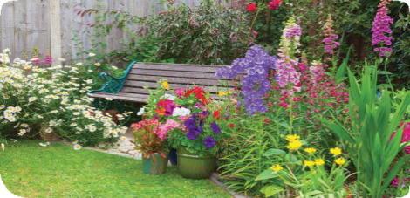

July 2017

Join us in the  English Country Garden  Honorary Chairs:  Mary & Howard Lincoln  Committee Members:  Mary Boldt  Denise Bielinski  Noel Burgoyne  Kathy Burns  Geri Cicchetti  Patty Herr  Kathy Hubbard  Nathan Koble  Kathy Pae  Linda Terella  Kathleen Whipple  Shirley Williams  Norm Zymm  Board of Directors:  Patricia Ambrose  Nancy Bennett  Mary Boldt  Greg Fischer  Patricia Herr  Kyle Hannon  Lynette Hughes  Christina Katen  Nathan Koble  Christine Konzel  Joyce Miller  Cheryl Mitchell  Amy Pound  Mary Schaaf | Dear Friend,  SafeNet will host its Fifth Annual Garden Party in the Big Backyard on Friday, July 28, 2017 at 6:00 p.m. We hope you will join us.  The Big Backyard is a beautiful park-like space dedicated to natural outdoor play for our children as well as kids in the neighborhood. Once a year, the space is transformed, creating a themed ambience. This year it will transform to an English garden.  We ask that you consider becoming a sponsor of the event. The funds raised will benefit the children who accompany parents who are recipients of SafeNet services. SafeNet serves nearly 500 children each year with direct counseling services or shelter. Children also benefit from prevention education available in area schools.  Your support helps children cope with what they have experienced in the home and will go far in stopping the generational cycle of abuse. The sponsorship levels are attached for your review.  Come join us and experience the beauty of an English garden in downtown Erie.  Thank you for your consideration. Questions – please call 814 455 1774 x 227.  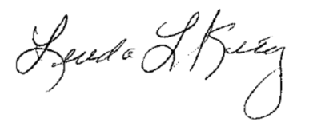  Sincerely,  Mary and Howard Lincoln  Linda Lyons King Mary and Howard Lincoln  Executive Director Honorary Chairs  Attachment
An English Garden
Sponsorship Levels for SafeNet’s 5th Annual Garden Party

Event Sponsor $15,000
VIP seating at the English Garden Party in the Big Backyard
20 tickets to the event
Inclusion in all press releases as event sponsor
Announcements from podium
Signage at the event

Cottage Sponsor $10,000
12 tickets to the English Garden Party in the Big Backyard
Announcements from podium
Inclusion on signage

Garden Sponsor $5,000
10 tickets to the English Garden Party in the Big Backyard
Announcements from podium
Inclusion on signage

Children’s Sponsor $2,500
8 tickets to the English Garden Party in the Big Backyard
Inclusion on signage

Benefactor Sponsor $1,000
6 tickets to the English Garden Party in the Big Backyard
Inclusion on signage

Friend Sponsor $600
4 tickets to the English Garden Party in the Big Backyard
Inclusion on signage

Host Sponsor $300
2 tickets to the English Garden Party in the Big Backyard
Inclusion on signage

